XYZ Project Dashboard
Statement of Work

September 14, 2010

Table of Contents
Table of Contents 2
Project Overview 3
Implementation Phase Timeline 3
Activities and Work Products 4
PROJECT STAFFING 5
KEY PROJECT ROLES FROM CAPGEMINI 7
Proposed Team 8
Professional Fees 9
Overall Project Assumptions 10
Project Change Control Procedure 11

This Statement of Work (“SOW”) sets forth the Services to be provided by Capgemini U.S. LLC (“Capgemini”) to The XYZ Company LLC (“XYZ”). This SOW shall be governed by and interpreted in accordance with the Master Services Agreement, dated July 15, 2009 (the “Agreement”) by and between XYZ and Capgemini. Capitalized terms used in this SOW and not otherwise defined herein shall have the meaning as set forth in the Agreement.

Project Overview
XYZ has requested Capgemini to assist in the development of Executive and Management Dashboard building project (project Dashboard). The Dashboard project will leverage the new SAP Business Objects Business Intelligence platform to deliver standardized business relevant KPIs through strategic scorecards, reports and analytics. The Dashboard project is one of several strategic initiatives being undertaken by XYZ; hence the timing of the project is critical and needs align to the ongoing projects.

This engagement leverages the work completed by the project team during the plan phase. The work products leveraged are:

- A high-level architecture that will support the construction of Dashboard project;
- A high-level project plan for the Implementation phase, staffing requirements, resource capability requirements, and XYZ personnel requirements.

The scope of this engagement is comprised of the following activities:

- BI report-mapping documents utilizing input from CPG SME
- Facilitate implementation of a BI framework for XYZ executive reporting needs
- Identify the underlying data structures to support the above BI framework
- Phase 1 KPI’s will support the BI framework for Brand, Customer and Region and summarized financial statements
- Delivery of up to seven (7) Xcelsius dashboards
- Delivery of a combination of up to twelve (12) Web Intelligence / Crystal reports
- The above dashboards and reports will be sourced from existing SAP BW 7 production system
- Up to five (5) end-user training sessions to champion and facilitate use of the dashboards and reports
- Capgemini will provide technical direction and assistance where appropriate for the development of the iViews for consumption by the Scott’s portal team and integration of SAP and BWA EP7 for placement in the Scott’s Garden Workbench.

Implementation Phase Timeline

The estimated project duration is approximately 7 months. The anticipated projected start date is August 16, 2010 with estimated completion date of March 18, 2011. Capgemini will perform the Services on-site at Client’s offices in Marysville, OH and remotely at Capgemini facilities.

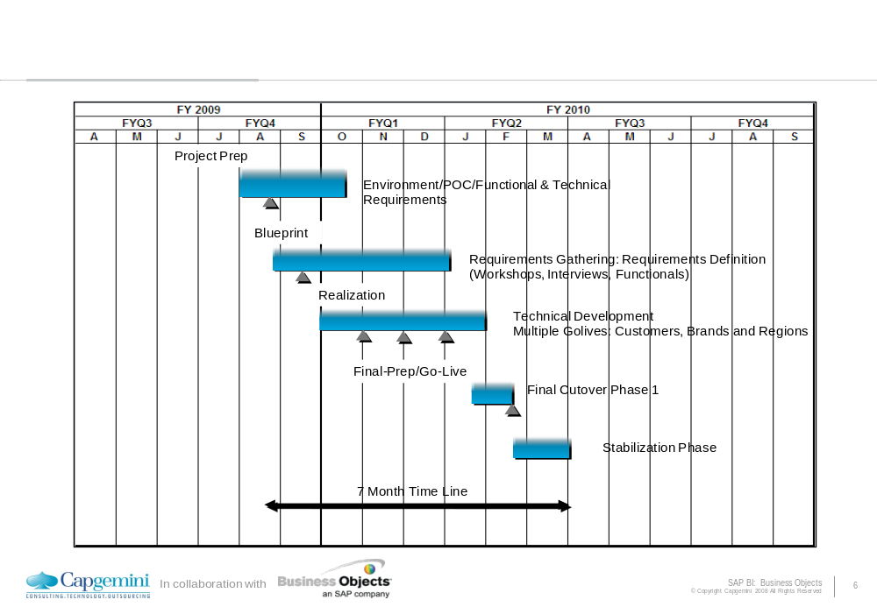

Capgemini will support multiple “mini” go-lives during the realization phase. Upon delivery of the first dashboard and reports there will be a stabilization period where users can access and acceptance-test the deliverables in a controlled fashion. The second mini-go live will take into account user feedback to refine the dashboard and reports, and re-release. The third mini go-live will release the remaining dashboards and reports, provide additional data enhancements and functionality and BW EP 7 rendering.

Activities and Work Products

The following section further defines the scope of the Services that will be provided by Capgemini under this SOW. Any activity that is not specified below is out-of-scope for the project and this SOW and Capgemini has no responsibility or obligation with respect to any such activity.

- Provide mapping documents for identified reports by the CPG SME and team. Identify the data structures necessary for the BI framework to support the KPI’s as related to Brand, Customer and Region and summarized financial statements.
- Prioritize the Phase I KPI’s with a maximum of fifteen (15) base and calculated KPI’s.
- Business confirmation of report samples based on fifteen (15) to twenty-five (25) reports.
- Provide mapping documents for identified reports.

- Delivery of up to seven (7) Xcelsius dashboards.

- Delivery of a combination of up to twelve (12) Web Intelligence / Crystal reports.

- Design, development and testing of BI queries that support the dashboards and reports.
- Design, development and testing of InfoProviders that support the dashboards and reports.
- Evaluation of dashboards and Webi reports for rationalization of the necessary reports and dashboards.
- Business Objects Universe design leading practices document.
- Leverage existing BW infocubes and queries to build BO Universes.
- Work with XYZ Portals team to deliver Dashboards via internal SAP EP 7 (Resource and rendering will be the responsibility of XYZ).
- Capgemini will provide thought leadership for BO integration and interface to SAP EP7 for information broadcasting e.g. desktop, EP, etc.
- Execute unit and system test cycle.
- Participate/facilitate UAT (User Acceptance Testing).
- Define and coordinate organization change management procedures.
- Provide up to five (5) end-user training sessions to champion and facilitate use of the dashboards and reports.
- Review project results with XYZ executive management.

Staffing and Project Responsibilities

PROJECT STAFFING

The figure below articulates the anticipated staffing on the project.

Capgemini will phase the on-boarding of the Capgemini resources that will perform the Services as set forth in this SOW and Capgemini will utilize an offshore team (provided by an affiliate of Capgemini) to perform the Services as set forth in this SOW.

In addition, the staffing of the anticipated Capgemini project team is subject to the following assumptions:

- The core Capgemini project team to support the build for project Dashboard phase 1 will be comprised of a team of six (6) resources onsite.
- The Capgemini Project Manager will be full-time onsite on the engagement for the duration of the project.
- The Capgemini Solution Architect will be full-time onsite on the engagement until after second mini go-live after which this resource will spend approximately 1/day a week supporting the project.
- The Capgemini BOE Admin/Architect resource will be fulltime until first and second mini go-lives (10/1/2010 and 11/1/2010) and will be remote for the rest of the engagement with an overlap period provided for handoff /synchronization of duties.
- Capgemini BO Webi/Universe designer:
  - One resource will be onsite for the duration of the project
  - Second resource will be onsite starting after first mini go-live (10/1/2010) after which this resource will be fulltime remote.
- Capgemini Xcelsius Developer resource will be onsite starting September 2010 fulltime to help deliver first and second mini go-lives, this resource will be remote starting December 2010.
- Capgemini Offshore Coordinator will facilitate 3 resources from 11/15/2010 to 2/13/2010
  - BO Webi/Crystal Developer
  - BO XL Developer
  - BOE Admin.
- Capgemini Delivery Executive for 16 hours per month throughout duration of project.
- Project assumes access to XYZ functional users during project development:

Staffing Plan
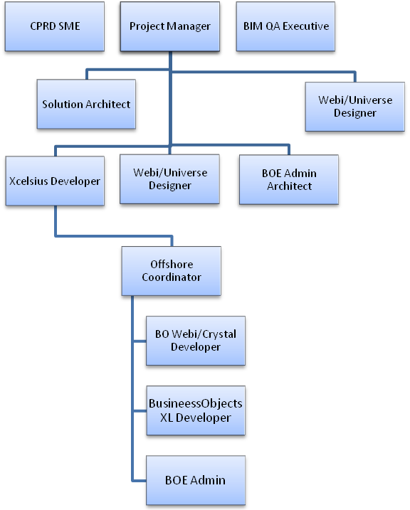

KEY PROJECT ROLES FROM CAPGEMINI

Capgemini Project Manager
- Manage project scope, progress, timeline and budget.
- Develop and manage project work plan, Project schedule/task Tracking.
- Provide guidance to the onsite team as well as off-shore team on the leading practices in the domain.
- Responsible for Quality Control (QC) of project.
- Inspection/review of tasks as per the plan.
- Prepare Detail Level Specifications, Review Specifications & Conduct Code Reviews, Unit Test Case Document Review.
- Provide that all Deliverables are in material accordance with the agreed upon coding standards. Responsible for Orientation/Training of the respective development team.

Solutions Architect:
- Overall responsibility for the Business Objects Reporting Delivery.
- Gather Requirements on the KPIs that needs to be tracked as well as their ideal tolerance ranges.
- Drive analysis for reports and dashboards.
- Work with solution delivery to write detailed functional specifications translating business requirements in functional constructs.
- Work with SAP BW development to help provide that the functional specifications are understood and delivery timeline agreed.
- Drive definition of data attributes, calculations, metrics and entities by working with solution delivery and development team.

Business Objects Administrator:
- Administer defined policies and procedures for ensuring the security and integrity of the Business Objects Environment.
- Work with all appropriate parties to resolve performance issues.
- Familiar with industry standards and leading practices for Business Object administration,
- Server sizing requirements for scalability based on user group and rollout.
- Monitor the weekly jobs and publications in R3.
- Help provide for the integration with EP 7 and BWA.

Business Objects WEBI/Universe Developer:
- Responsible for designing Universes on SAP BI.
- Responsible for designing Reports as per the requirement.
- Responsible for implementing the Business Objects Leading Practices.
- Analysis of information from users to build executive reports with Webi / Crystal.
- Work with solution architect to build a reporting architecture.
- Work with user community to develop functional specifications for development.
Business Objects Xcelsius developer:
- Analysis of information from users to build executive dashboards.
- Work with solution architect to build a reporting architecture.
- Work with user community to develop functional specifications for development.

Proposed Team

Role | Resource | Activities
Project Advisor / Delivery Exec | Andy | Will serve in a project advisor role, providing strategic direction and providing periodic checkpoints with XYZ leadership on project progression.
Project Manager | Sue | Project Manager with delivery leadership and execution responsibilities for the XYZ PRM Project.
SAP Solutions Architect |  | Solutions Architect with technical architecture, design and implementation responsibilities for the XYZ PRM Project.
SAP BO Webi/Universe Developer (2)
SAP BO Admin | TBD
SAP BO Xcelsius Developer | TBD
BIM QA Executive |  | Executive sponsor who will serve as a QA executive from a technology/information strategy perspective.

Professional Fees
Capgemini’s professional fees for the Services as set forth in this SOW will be calculated on a time and materials basis, based on the actual hours worked by the Capgemini resources in performing the Services. In addition to Capgemini’s professional fees, XYZ will be invoiced for Capgemini’s out-of-pocket expenses incurred in connection with this SOW, which will be invoiced to XYZ based on the actual amount of such out-of-pocket expenses. The out-of-pocket expenses are estimated to be fifteen percent (15%) of Capgemini’s professional fees. A summary of the estimated professional fees and expenses for the Services as set forth in this SOW is provided below. Capgemini will invoice XYZ on a monthly basis for Capgemini’s professional fees and expenses and XYZ will pay Capgemini’s invoices within forty-five (45) days of receipt of each such invoice.

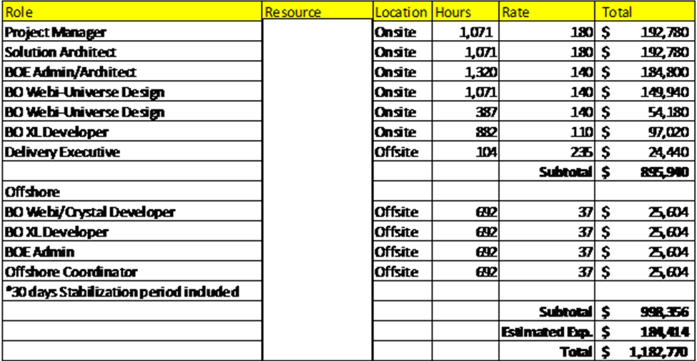

Overall Project Assumptions
- The hourly rates as set forth above are based on the rate card previously agreed to between Capgemini and XYZ.
- The SAP and BW environments and all necessary client software will be made available for development and supplied by XYZ.
- Any increase in the base/calculated number of KPI’s will result in an increase in scope impacting project timeline and cost.
- The staffing and scope for the Services to be performed by Capgemini pursuant to this SOW are as set forth in this SOW.
- Capgemini expects that there will be a level of time commitment required by XYZ’ employees. Guidelines on that level of commitment are as set forth below:
  - XYZ will make all necessary and appropriate resources available as needed per the project schedule.
  - XYZ will
- Capgemini recommends a staff which includes a mix of onshore and offshore resources.
- No parameterization of the dashboards to link to Webi or crystal reports is expected.
- A dedicated BW Developer resource will be supplied by XYZ.
- Resources for BW Query and BW InfoProviders building will be supplied by XYZ.
- Realistic data for testing will be provided by XYZ. It is assumed that this test data is representative, or an exact copy of the production environment.
- The scope of this project is for phase I Deliverables of dashboards and Webi reports and does not encompass any reporting or enhancements in SAP BI 7.01.
- The BI framework is a series of dimensions, measures and hierarchies for ad-hoc reporting and analysis. The final design of the framework will take into consideration limitations inherent within the current releases of the SAP Business Objects/BW environment.
- XYZ will acquire and install the Business Warehouse Accelerator product prior to the testing phase of the first mini go-live.
- The estimates and project plan within this SOW are subject to change, based on further refinement of project requirements. This refinement is expected to be completed no later than mid-October.
- Capgemini is not responsible for the addition data elements to include hierarchies in the SAP BW layer. When requirements and scope dictate the need for new hierarchies, Dashboard Business Objects design and development tasks will be dependent on the creation of these hierarchies in SAP.

In addition, XYZ acknowledges that delays or work stoppages either requested by XYZ or that result solely from XYZ’ failure to timely provide personnel; information, materials or other resources as agreed upon may result in changes to the project budget, scope, and/or timeline and the need for a project change request to be raised.

Project Change Control Procedure
Detailed below is the process to follow if a change to this SOW is required. The following change control procedures are subject to the terms of the Agreement.

- A Project Change Request (“PCR”) will be the vehicle for communicating change. The PCR must describe the change; the rationale and the effect the change will have on the project (e.g., alterations to Deliverables, acceptance criteria, etc.).
- The designated Project Manager of the requesting party will review the proposed change and determine whether to submit the request to the other party.
- Both Project Managers for this SOW must agree to the proposed change(s) and secure their appropriate internal reviews and/or approvals.
- A PCR will not be effective until a mutual approval from both the parties has been obtained and signed by XYZ and Capgemini.
Accepted and approved by:

Capgemini U.S. LLC The XYZ Company LLC

By: __________________________ By: __________________________

Print Name: Mr. Vice President Print Name: Mr. CIO

Title: Vice President Title: CIO

Date: Date:

